The Civil War 6.1

SSUSH9 Evaluate key events, issues, and individuals relating to the Civil War.
a. Explain the importance of the growing economic disparity between the North and the South through an examination of population, functioning railroads, and industrial output.
Northern vs Southern Economy
Document Analysis 1
b. Discuss Lincoln’s purpose in using emergency powers to suspend habeas corpus, issuing the Emancipation Proclamation, and delivering the Gettysburg and Second Inaugural Addresses.
Abraham Lincoln's use of Emergency Powers: Suspends Habeas Corpus
Document Analysis 2
Privilege of the Writ of Habeas Corpus shall not be suspended, unless when in Cases of Rebellion or Invasion the public Safety may require it.
Source: The Constitution: Article I, Section 9, Clause 2
Lincoln was glad that several slave states elected to stay with the Union. He realized, however, that southern sympathizers were common in these areas. If Maryland joined the Confederacy, the Union capital of Washington, DC would be surrounded by Confederate territory. Concerned that Confederate sympathizers might successfully sway Maryland to secede, President Lincoln took drastic action. He declared martial law in Maryland, suspended the writ of habeas corpus (the guarantee that a person cannot be imprisoned without being brought before a judge) and jailed the strongest supporters of the Confederacy. This allowed the Maryland legislature to vote in favor of remaining with the Union. Lincoln continued to use habeas corpus throughout the war to suppress confederate supporters in the norther states.
Abraham Lincoln's use of Emergency Powers: Issuing the Emancipation Proclamation
On January 1, 1863, following a much needed Union victory at Antietam, Maryland, President Lincoln issued the Emancipation Proclamation. This proclamation freed the slaves in the Confederate States, while maintaining slavery in the Border States loyal to the Union. (Lincoln still needed the support of these states and could not yet risk alienating them by forcing them to give up slavery.) With this executive order, Lincoln hoped to give the war a moral focus by making freeing the slaves the main issue and not just saving the Union. He also hoped to undermine the South's reliance on slave labor and ensure the support of England and France, both of which had already abolished slavery. The Emancipation Proclamation also encouraged free African Americans to serve in the Union army. Although originally not allowed to enlist, early Union defeats led Congress to authorize accepting African Americans into the army in 1862. On warships, whites and blacks served side by side. In the army, however, African Americans served only in all black regiments under the command of white officers. Seeing their battle as one to free their own people from the bonds of slavery, African Americans served notably during the war. One of the most valiant African American units, the 54th Massachusetts, actually saw its first action in Georgia. The movie Glory tells the story of the 54th Massachusetts.
c. Examine the influences of Ulysses S. Grant, Robert E. Lee, Thomas “Stonewall” Jackson, William T. Sherman, and Jefferson Davis.
Document Analysis 3
Document A | Document B
April 7th, 1865.  To General R.E. Lee Commanding C.S.A. [Confederate States of America]:  The results of the last week must convince you of the hopelessness of further resistance on the part of the Army of Northern Virginia in this struggle. I feel that it is so, and regard it as my duty to shift from myself the responsibility of any further effusion [loss] of blood by asking of you the surrender of that portion of the Confederate States army known as the Army of Northern Virginia.  From: Ulysses S. Grant | April 7th, 1865.  To General Grant :  I have received your note of this day. Though not entertaining the opinion you express of the hopelessness of further resistance on the part of the Army of Northern Virginia, I reciprocate [agree with] your desire to avoid useless effusion [loss] of blood, and therefore, before considering your proposition, ask the terms you will offer on condition of its surrender.  From: R.E. LEE, General.

Union Leaders
Ulysses S. Grant
Initially an effective general in the Union's western battles, he eventually assumed command of the entire Union army in 1864. He defeated the South and accepted Robert E. Lee's surrender at Appomattox Courthouse. He went on to become the 18th president of the United States.
William T. Sherman
Union general who took command of the western forces after Grant decided to remain with troops in the East. His capture of Atlanta in 1864 signaled to both the North and the South that the war was all but won for the Union and helped Lincoln win re-election in 1864. He is most remembered for his "march to the sea," in which he burned and destroyed southern cities and railways in an effort to disrupt the Confederate war effort and trap Lee between himself and General Grant.
Confederate Leaders
Jefferson Davis
First and only president of the Confederate States of America.
Robert E. Lee
Assumed command of the Confederacy's Army of Northern Virginia after General Joseph Johnston was injured. Despite winning several impressive victories during the course of the war, he did not have nearly enough men to sustain the war effort past early 1865. He eventually surrendered to General Grant.
Thomas “Stonewall” Jackson
Confederate general and right-hand man to Robert E. Lee. Noted for his ability to use geography to his advantage, he swiftly navigated the Shenandoah Valley which stretched from the Allegheny Mountains in northern Virginia north towards Washington, D.C. One of his most brilliant moves came at the battle of Chancellorsville, when he successfully marched his troops over 12 miles undetected and attacked the unsuspecting Union forces. Jackson was such an effective leader that many believe the South would have won the war had he lived to fight at Gettysburg.
d. Explain the importance of Fort Sumter, Antietam, Vicksburg, Gettysburg, Atlanta and the impact of geography on these battles.
Fort Sumter
President Abraham Lincoln knew he could not let the South secede. However, he also knew that US citizens had different opinions about going to war. Many northerners were sick of the slavery debate. They wanted Lincoln to let the South leave and take their disgusting slavery with them. Others wanted to preserve the Union but favored negotiating (talking to work out a peaceful solution) with the South. Only a few favored force. As a result, Lincoln did not have enough support to launch any military action against the Confederacy even if he wanted to. If there was going to be a war, the South would have to start it.
In April, 1861, Union troops located at Fort Sumter, South Carolina, were running low on supplies. Lincoln sent word to the governor of South Carolina that he was sending ships with food for the soldiers but no weapons. South Carolina would not tolerate Union troops so close to home any longer, however, and on April 12, Confederate forces opened fire. The South's attack forced the Union troops to leave the fort, but it also gave Lincoln the support he needed. Many northerners who at first opposed the war now felt the Union had been attacked. They were ready to support their president if he decided war was necessary. In response, President Lincoln issued a call for 75,000
volunteers. Border States (slave states in the Upper South) were forced to decide whether to support the Union or the Confederacy. With a great deal of controversy and division, Kentucky, Missouri, Maryland, and the northwest regions of Virginia remained in the Union, while the rest of Virginia, North Carolina, Arkansas and Tennessee joined the Confederacy. The capital of the Confederacy was then moved from Montgomery, Alabama to Richmond, Virginia. The Civil War had begun.
Battle of Antietam
Lee and his generals tried to maintain secrecy as they made preparations for their invasion. Meanwhile, General McClellan (the Union's commanding general), remained unaware of the Confederate army's whereabouts until a copy of Lee's orders were found wrapped around some cigars at an abandoned Confederate camp. Now aware of Lee's plans, McClellan saw to it that Lee met a prepared Union force at Antietam Creek, Maryland. The battle of Antietam proved to be the bloodiest single day of the war, halting the Confederate advance. McClellan hesitated, however, and Lee's army slipped away to fight another day. On January 1, 1863, following a much needed Union victory at Antietam, Maryland, President Lincoln issued the Emancipation Proclamation.
Battle of Vicksburg
In the late spring of 1863, the town of Vicksburg, Mississippi was the last Confederate obstacle to total Union control of the Mississippi River. Ignoring advice to withdraw, General Ulysses S. Grant laid siege (a strategy by which an army surrounds its enemy, cuts off their supplies, and starves them into surrendering) to Vicksburg for almost two months. By the time the town finally surrendered on July 4, residents had been reduced to eating horses, mules, dogs, and even rats. As a result of the battle, the South loses control of the Mississippi River and Texas, Arkansas, and Louisiana troops are cut off from the war effort.
Battle of Gettysburg
Fought just outside Gettysburg, Pennsylvania, the battle of Gettysburg was a key turning point in the war. Without Jackson to assist him, Lee's forces proved less aggressive than usual and failed to win valuable high ground early in the battle. Union forces under the command of General George Meade defeated Lee's army and ended any hope the South had of successfully invading the North. With more than 51,000 soldiers killed, wounded, or missing, Gettysburg was the bloodiest battle of the entire Civil War. Four months later President Lincoln gave his famed Gettysburg Address at a ceremony dedicating a cemetery on the sight of the battlefield. Although a relatively short speech, it was a powerful affirmation that the civil war was fought over the issue of slavery and union soldiers should continue to fight for the fallen soldiers.
Battle of Atlanta
In 1864, Lincoln appointed Grant to be overall commander of the entire Union army. Grant decided to take command of the eastern forces and put his most trusted general, William T. Sherman, in charge of his western forces. In May 1864, Sherman began an invasion of Georgia. He wanted to reach Atlanta because of its importance as a railway hub. If Sherman took Atlanta, he could seriously hurt the South by disrupting its major rail lines. As Sherman advanced south, General Johnston's Confederate forces tried to delay his march with several small attacks. Johnston did not want to meet Sherman in a full-scale battle because Sherman had more men and Johnston feared that a defeat would mean the end of his army. Finally, after a series of bloody fights, Johnston's forces prepared to make their stand just north of Atlanta at Kennesaw Mountain. When a direct assault on Kennesaw Mountain failed, Sherman decided to flank (move around) Johnston's army to reach Atlanta. The move worked and, on July 8, the first Union forces crossed the Chattahoochee River to reach the outskirts of Atlanta. Jefferson Davis was furious with Johnston for not engaging Sherman in a full-scale battle and replaced him with General John Bell Hood. By then, however, it was too late. Hood evacuated the city on September 1, 1864, and Sherman's army moved into Atlanta the very next day. Sherman's successful Atlanta campaign not only placed the city under Union control, it also reignited support for President Lincoln in the North. Before Atlanta, many northerners wanted to negotiate with the South and end the war. After Sherman's success at the Battle of Atlanta, however, people in the Union believed victory was in sight and re-elected Lincoln to a second term.
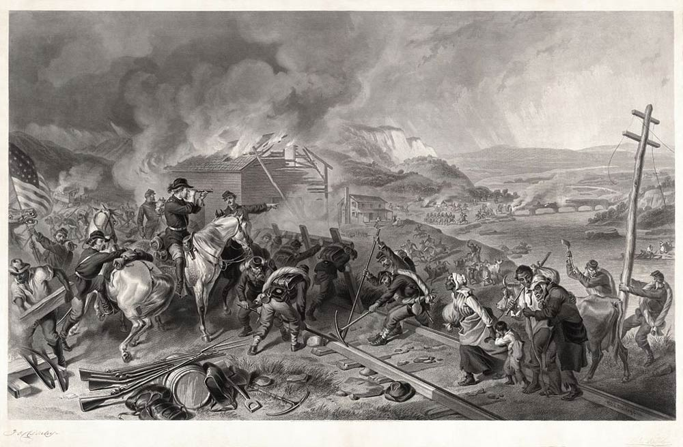
Document Analysis 4

After taking Atlanta, Sherman ordered much of the city burned. He then began a march from Atlanta to Savannah that became known as his march to the sea. On its way to the coast, Sherman's army burned buildings, destroyed rail lines, set fire to factories, and demolished bridges. Sherman hoped to cripple the South's ability to make and ship supplies so that it could not keep fighting. People in Savannah were so terrified by news of the destruction that, when Sherman finally reached the city, they surrendered without a fight. Sherman then turned north into the Carolinas. All the while, General Joseph Johnston continued trying to resist Sherman as best he could.

