American Revolution 2.2
SSUSH4 Analyze the ideological, military, social, and diplomatic aspects of the American Revolution. Endeavors
d. Investigate the role of geography at Battles of Trenton, Saratoga, and Yorktown.
American Revolution
The American Revolution actually began long before the Declaration of Independence was ever written. By the time delegates to the Second Continental Congress signed the document in the summer of 1776, colonists and British forces had been fighting for over a year. King George III of England did not expect a long war. After all, the British possessed one of the world's most formidable armies and its mightiest navy. How could a disorganized band of untrained colonists possibly defeat them? The colonists, however, enjoyed one advantage that the British did not; they were fighting for their homeland and the right to govern themselves. This made them more determined, if not more prepared, to win the war. In addition, many colonists had fought alongside the British in the French and Indian War and were familiar with their tactics. Colonial leaders also knew that, if they failed, they would all hang for treason. In short, the American colonists had no option but victory.
American Revolution
20. Who was the king of England?
21. Why did the British and King George II not expect a long war?
22. What were two advantages that the colonist had over the British?
Document Analysis 2
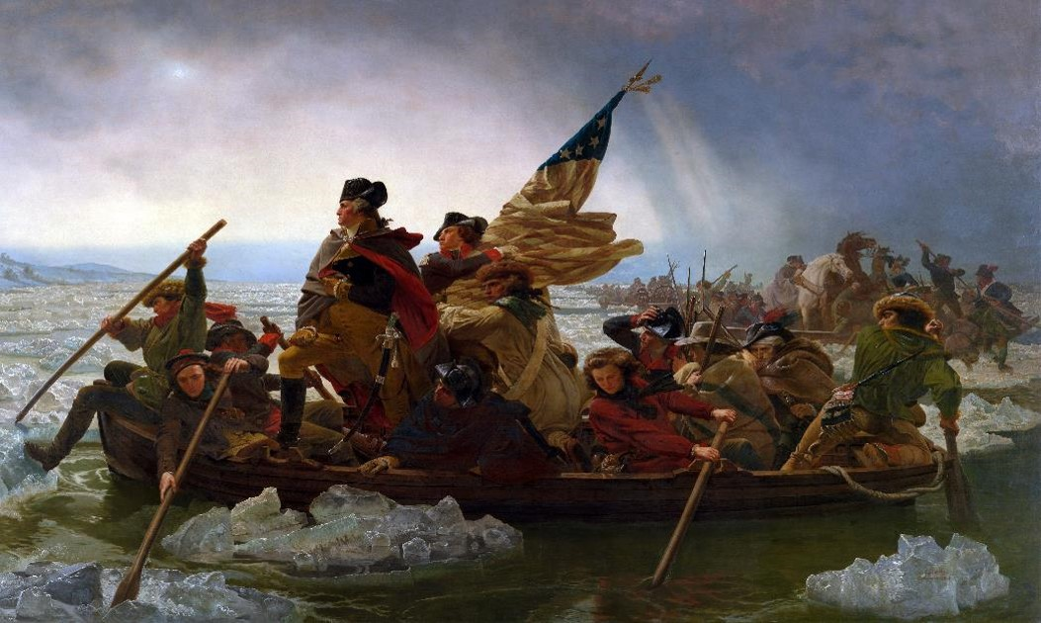
Document Analysis 2
23. Based on your knowledge of history, what historical event is being described by the image?
24. Based on your knowledge of history, what historical figure is leading the attack?
25. Based on your knowledge, is the image historically accurate?
Battle of Trenton
A month later, General George Washington arrived, after being appointed by the Continental Congress to command the American army. In March, 1776, the British left Boston and eventually made their way to New York. There, despite his best efforts, the British forced Washington to abandon the city and start a long and humiliating retreat. Plagued by a lack of supplies, undisciplined soldiers, and the desertion of many of his troops (either illegally or because their enlistments had expired), Washington and his army seemed on the brink of defeat. Then, in December 1776, Washington made a daring move. He surprised his enemy by crossing the Delaware River on Christmas night and attacking the Hessians (Germans hired to fight for the British) and subsequent Battle of Trenton (New Jersey).
Having finally tasted victory at the Battle of Trenton, Washington's troops did not let up. Leaving their camp fires burning so as to make the enemy think they were still there, Washington's army slipped away in the middle of the night to launch another surprise attack at Princeton. Washington's victories in New Jersey greatly lifted American morale and gave people hope that, perhaps, the revolution could actually succeed.
Battle of Trenton
26. What city did the British force Washington to abandon?
27. What was Washington’s daring move in December 1776?
28. Did the Continental Army win the Battle of Trenton?
29. Summarize: What was the geographic significance of the Battle of Trenton?
Battle of Saratoga
The Battle of Saratoga is another critical battle from the Revolutionary War in which geography contributed to the American victory. The British plan to defeat the rebellious Americans was to take control of New York, which would drive a wedge between New England and the rest of the colonies. If the colonies were divided, the British believed the Americans would have no choice but to end the war. British commander General John Burgoyne was leading his forces south from Canada down Lake Champlain to the Hudson River. British General William Howe was to lead another force toward the north from New York City. The coordinated movements of the British was intended to secure the entire New York region. Howe, instead of trekking north as part of the plan to assist Burgoyne, pursued control of Philadelphia. Burgoyne subsequently was trapped by the Americans at Saratoga, New York and forced to surrender his forces.
The American commander who faced Burgoyne as the British moved south from Canada was General Horatio Gates. The British force was slowed because of the large supply convoy that traveled with Burgoyne. While Burgoyne slowly made his way from Canada toward the south, the Americans were steadily building fortifications on the high ground around Saratoga. Bemis Heights is a ridge that overlooks the Hudson River Valley where Burgoyne’s British forces were headed. Having cannon on top of the ridge and fortified walls at the base gave the Americans control of the area.
When Burgoyne’s British forces approached the fighting ensued. After a number of weeks of intense fighting, the British were surrounded and Burgoyne was forced to surrender on October 17, 1777. Controlling the high ground at Bemis Heights with fortifications at the Hudson River geographically contributed to the American victory at Saratoga. This victory is considered a turning point in the American Revolution because it signaled to France that the Americans had a chance of winning. The French had been reluctant of openly agree to an alliance with the Americans for fear that victory was not possible. The victory at Saratoga was just what Benjamin Franklin needed in his European negotiations for alliance and support of the American cause.
Battle of Saratoga
30. Why did the British want to win the Battle of Saratoga?
31. According to the British, what would happen if the colonies were divided?
32. The British and Burgoyne subsequently was trapped by the Americans at ____________________, New York and forced to _______________________his forces.
33. While British forces were slow to arrive from Canada, what were the Americans building at Saratoga?
34. What was the importance of Bemis Heights at Saratoga?
35. Summarize: What was the geographic significance of the Battle of Saratoga?
36. Why was the Battle of Saratoga considered a turning point in the American Revolution?
Battle of Yorktown
Eventually, British General Charles Cornwallis regrouped and invaded North Carolina. He pursued the southern US forces, now under the command of Nathanael Greene, hoping to force them into a decisive battle that would crush the revolution in the South. After leading the British on a long chase that extended into Virginia and forced Cornwallis to exhaust many of his supplies, Greene eventually engaged the British forces at the Battle of Guilford Courthouse at what is today Greensboro, NC. Cornwallis won, but at a heavy cost. To win the battle, he had to fire his cannons into the midst of the battle, killing many of his own men. In need of supplies, he marched his forces north to the coastal town of Yorktown, Virginia, where he hoped to receive what he needed from British ships. Realizing that Cornwallis was now trapped on the Virginia peninsula, Washington marched south to pin him between the Continental Army and the Atlantic Ocean. Meanwhile, the French navy provided a blockade that prevented British ships from coming to Cornwallis' rescue. On October 19, 1781, Cornwallis surrendered to Washington at Yorktown. So humiliated was the British general that he could not even deliver his sword in person. (In those days, the losing general gave his sword to the victorious general as part of a formal ceremony of surrender.)
Battle of Yorktown
37. Who was the British General in charge of the Southern Army?
38. What U.S. Commander fought against General Cornwallis?
39. Why did General Cornwallis settle his troop in Yorktown, Virginia?
40. What geographic feature cause General Cornwallis and the British to be trapped at Yorktown?
41. What was the role of the French navy during the Battle of Yorktown?
42. Who did General Cornwallis surrender to at the Battle of Yorktown?
43. Summarize: What was the geographic significance of the Battle of Yorktown?

