The Civil War 4.2

SSUSH9 Evaluate key events, issues, and individuals relating to the Civil War.
d. Explain the importance of Fort Sumter, Antietam, Vicksburg, Gettysburg, Atlanta and the impact of geography on these battles.
Fort Sumter
President Abraham Lincoln knew he could not let the South secede. However, he also knew that US citizens had different opinions about going to war. Many northerners were sick of the slavery debate. They wanted Lincoln to let the South leave and take their disgusting slavery with them. Others wanted to preserve the Union but favored negotiating (talking to work out a peaceful solution) with the South. Only a few favored force. As a result, Lincoln did not have enough support to launch any military action against the Confederacy even if he wanted to. If there was going to be a war, the South would have to start it.
In April, 1861, Union troops located at Fort Sumter, South Carolina, were running low on supplies. Lincoln sent word to the governor of South Carolina that he was sending ships with food for the soldiers but no weapons. South Carolina would not tolerate Union troops so close to home any longer, however, and on April 12, Confederate forces opened fire. The South's attack forced the Union troops to leave the fort, but it also gave Lincoln the support he needed. Many northerners who at first opposed the war now felt the Union had been attacked. They were ready to support their president if he decided war was necessary. In response, President Lincoln issued a call for 75,000
volunteers. Border States (slave states in the Upper South) were forced to decide whether to support the Union or the Confederacy. With a great deal of controversy and division, Kentucky, Missouri, Maryland, and the northwest regions of Virginia remained in the Union, while the rest of Virginia, North Carolina, Arkansas and Tennessee joined the Confederacy. The capital of the Confederacy was then moved from Montgomery, Alabama to Richmond, Virginia. The Civil War had begun.
26. Many ___________________________ wanted Lincoln to let the South __________________ and take their disgusting slavery with them. Others wanted to ___________________ the Union but favored negotiating (talking to work out a peaceful solution) with the South.
27. Lincoln did not have enough support to launch any _________________________ action against the Confederacy even if he wanted to. If there was going to be a war, the __________________________ would have to start it.
28. Why did Lincoln send to Union Troops located at Fort Sumter, South Carolina?
29. How did Confederate troops respond to Lincoln?
30. Summarize: What was the significance of Fort Sumter during the Civil War?
Battle of Antietam
Lee and his generals tried to maintain secrecy as they made preparations for their invasion. Meanwhile, General McClellan (the Union's commanding general), remained unaware of the Confederate army's whereabouts until a copy of Lee's orders were found wrapped around some cigars at an abandoned Confederate camp. Now aware of Lee's plans, McClellan saw to it that Lee met a prepared Union force at Antietam Creek, Maryland. The battle of Antietam proved to be the bloodiest single day of the war, halting the Confederate advance. McClellan hesitated, however, and Lee's army slipped away to fight another day. On January 1, 1863, following a much needed Union victory at Antietam, Maryland, President Lincoln issued the Emancipation Proclamation.
31. How did Union General McClellan find out about General Lee’s Plans?
32. The battle of Antietam proved to be the __________________ single day of the war, halting the Confederate advance.
33. Summarize: What was the significance of the Battle of Antietam during the Civil War?
Battle of Vicksburg
In the late spring of 1863, the town of Vicksburg, Mississippi was the last Confederate obstacle to total Union control of the Mississippi River. Ignoring advice to withdraw, General Ulysses S. Grant laid siege (a strategy by which an army surrounds its enemy, cuts off their supplies, and starves them into surrendering) to Vicksburg for almost two months. By the time the town finally surrendered on July 4, residents had been reduced to eating horses, mules, dogs, and even rats. As a result of the battle, the South loses control of the Mississippi River and Texas, Arkansas, and Louisiana troops are cut off from the war effort.
34. In the late spring of 1863, the town of ______________________, Mississippi was the last Confederate obstacle to total Union control of the ______________________ River.
35. By the time the town surrendered what were the residents eating?
36. Summarize: What was the significance of the Battle of Vicksburg during the Civil War?
Battle of Gettysburg
Fought just outside Gettysburg, Pennsylvania, the battle of Gettysburg was a key turning point in the war. Without Jackson to assist him, Lee's forces proved less aggressive than usual and failed to win valuable high ground early in the battle. Union forces under the command of General George Meade defeated Lee's army and ended any hope the South had of successfully invading the North. With more than 51,000 soldiers killed, wounded, or missing, Gettysburg was the bloodiest battle of the entire Civil War. Four months later President Lincoln gave his famed Gettysburg Address at a ceremony dedicating a cemetery on the sight of the battlefield. Although a relatively short speech, it was a powerful affirmation that the civil war was fought over the issue of slavery and union soldiers should continue to fight for the fallen soldiers.
37. What state was the Battle of Gettysburg fought in?
38. What did Lee’s troops fail to win at the Battle of Gettysburg?
39. Summarize: What was the significance of the Battle of Gettysburg during the Civil War?
40. Summarize: Why did Lincoln deliver the Gettysburg Address? (What was the speech about?)
Battle of Atlanta
In 1864, Lincoln appointed Grant to be overall commander of the entire Union army. Grant decided to take command of the eastern forces and put his most trusted general, William T. Sherman, in charge of his western forces. In May 1864, Sherman began an invasion of Georgia. He wanted to reach Atlanta because of its importance as a railway hub. If Sherman took Atlanta, he could seriously hurt the South by disrupting its major rail lines. As Sherman advanced south, General Johnston's Confederate forces tried to delay his march with several small attacks. Johnston did not want to meet Sherman in a full-scale battle because Sherman had more men and Johnston feared that a defeat would mean the end of his army. Finally, after a series of bloody fights, Johnston's forces prepared to make their stand just north of Atlanta at Kennesaw Mountain. When a direct assault on Kennesaw Mountain failed, Sherman decided to flank (move around) Johnston's army to reach Atlanta. The move worked and, on July 8, the first Union forces crossed the Chattahoochee River to reach the outskirts of Atlanta. Jefferson Davis was furious with Johnston for not engaging Sherman in a full-scale battle and replaced him with General John Bell Hood. By then, however, it was too late. Hood evacuated the city on September 1, 1864, and Sherman's army moved into Atlanta the very next day. Sherman's successful Atlanta campaign not only placed the city under Union control, it also reignited support for President Lincoln in the North. Before Atlanta, many northerners wanted to negotiate with the South and end the war. After Sherman's success at the Battle of Atlanta, however, people in the Union believed victory was in sight and re-elected Lincoln to a second term.
41. What did Sherman begin in May 1864?
42. Why did Sherman want to take Atlanta?
43. Summarize: What was the significance of the Battle of Atlanta during the Civil War?
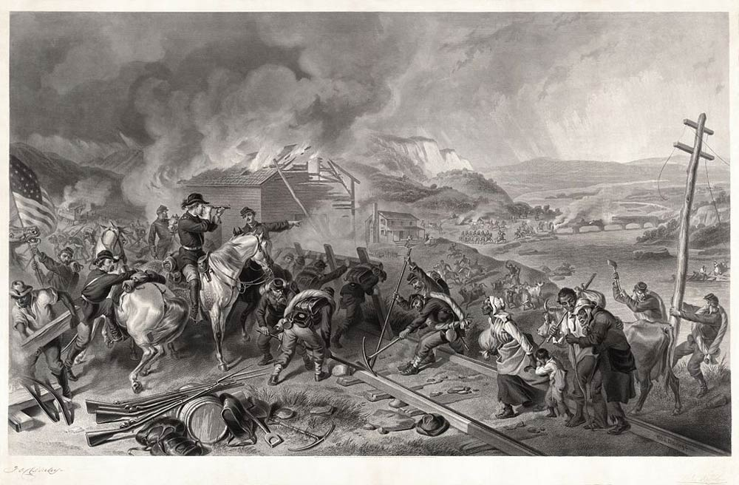
Document Analysis 4
44. What were the soldiers trying to destroy in the image?
45. Based on your knowledge of U.S. History, what city were the Union troops trying to destroy?

After taking Atlanta, Sherman ordered much of the city burned. He then began a march from Atlanta to Savannah that became known as his march to the sea. On its way to the coast, Sherman's army burned buildings, destroyed rail lines, set fire to factories, and demolished bridges. Sherman hoped to cripple the South's ability to make and ship supplies so that it could not keep fighting. People in Savannah were so terrified by news of the destruction that, when Sherman finally reached the city, they surrendered without a fight. Sherman then turned north into the Carolinas. All the while, General Joseph Johnston continued trying to resist Sherman as best he could.
46. What did Sherman order his troops to do to Atlanta after the battle?
47. Where did Sherman march to after Atlanta?
48. Summarize: What was the significance of Sherman’s March to the Sea during the Civil War?

