Background:

Expanding Suffrage in the United States (i.e. Jacksonian Democracy):

Election of 1824 and the “Corrupt Bargain”:

Election of 1828:

Development of the Second Party System:

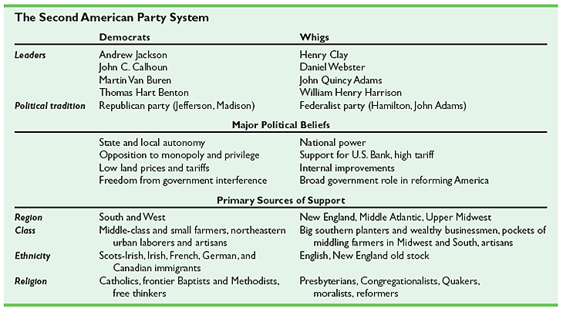

Spoils System:

Tariff of Abominations and the Nullification Crisis (1828-1833):

The Bank War - Andrew Jackson vs. the Second Bank of the United States:

Indian Removal Act of 1830:

