American Progress by John Gast, 1872

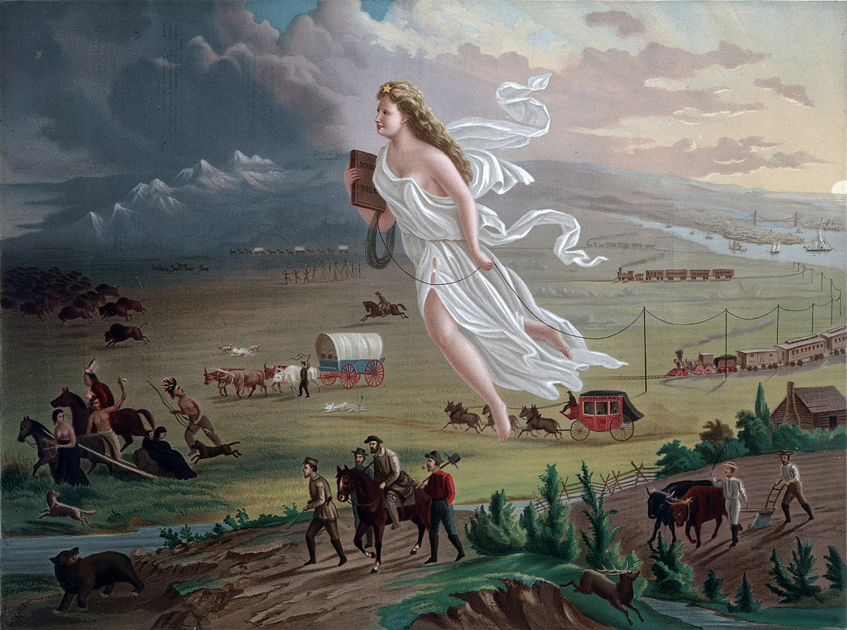

- Describe what you see in the image above:

- What do you think the figure in white represents? Why would the artist use this type of imagery?

- What is she carrying and what trails behind her? Why?

- Describe the difference between the landscape on the right (eastern) side of the painting and the landscape on the left (western) side of the painting. What is the symbolism there?

- What groups of people are represented in the painting? How do they differ?

- This painting, titled American Progress, is a visual representation of manifest destiny. Based on your analysis of the painting, make an educated guess as to what manifest destiny is? (Hint: Based on this image, what did Americans believe it was their destiny to do?)

