Fort Sumter
Fort Sumter is an island fortification located in Charleston Harbor, South Carolina. Originally constructed in 1829 as a coastal garrison, Fort Sumter is most famous for being the site of the first shots of the Civil War (1861-65). U.S. Major Robert Anderson occupied the unfinished fort in December 1860 following South Carolina’s secession from the Union, initiating a standoff with the state’s militia forces. When President Abraham Lincoln announced plans to resupply the fort, Confederate General P.G.T. Beauregard bombarded Fort Sumter on April 12, 1861. After a 34-hour exchange of artillery fire, Anderson and 86 soldiers surrendered the fort on April 13. Confederate troops then occupied Fort Sumter for nearly four years, resisting several bombardments by Union forces before abandoning the garrison prior to William T. Sherman’s capture of Charleston in February 1865. After the Civil War, Fort Sumter was restored by the U.S. military and manned during the Spanish-American War (1898), World War I (1914-18) and World War II (1939-45).

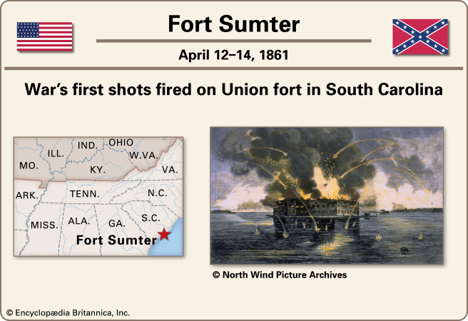

Antietam
For weeks, the tide of the Civil War ran in favor of the Confederacy. The morale of the North had been lowered by Gen. George B. McClellan's disastrous Peninsular Campaign in Virginia in 1862. As a result President Lincoln was forced to postpone issuing his Emancipation Proclamation for fear of seeming to appeal to blacks for aid in a losing cause. When he laid aside the proclamation, he vowed he would give it to the world after the first Union victory.
Instead of victory came more setbacks. General Robert E. Lee crossed the Potomac River, carrying the war into the North for the first time and striking terror into the hearts of the people of Maryland and Pennsylvania. Finally, on Sept. 17, 1862, his troops met the numerically superior forces of General George McClellan at the little creek of Antietam in Maryland. All day long the battle raged. The loss of men on each side was about 11,000. It remains the bloodiest single day of fighting in American history, with approximately 22,000-23,000 casualties.
No decisive results were obtained from the fierce conflict of that day. On the next day, however, Lee felt that it was wiser to withdraw from the field. Thus the victory seemed to be left with McClellan and the Union. Lee had not obtained the aid from the people of Maryland that he had expected, and so he retreated across the Potomac back into Virginia. McClellan made no attempt for a while to follow him, and so little military advantage was gained. Nevertheless the people of the North were encouraged, and Lincoln had the opportunity to issue his Emancipation Proclamation. For these two reasons the battle of Antietam was one of the important battles of the Civil War.

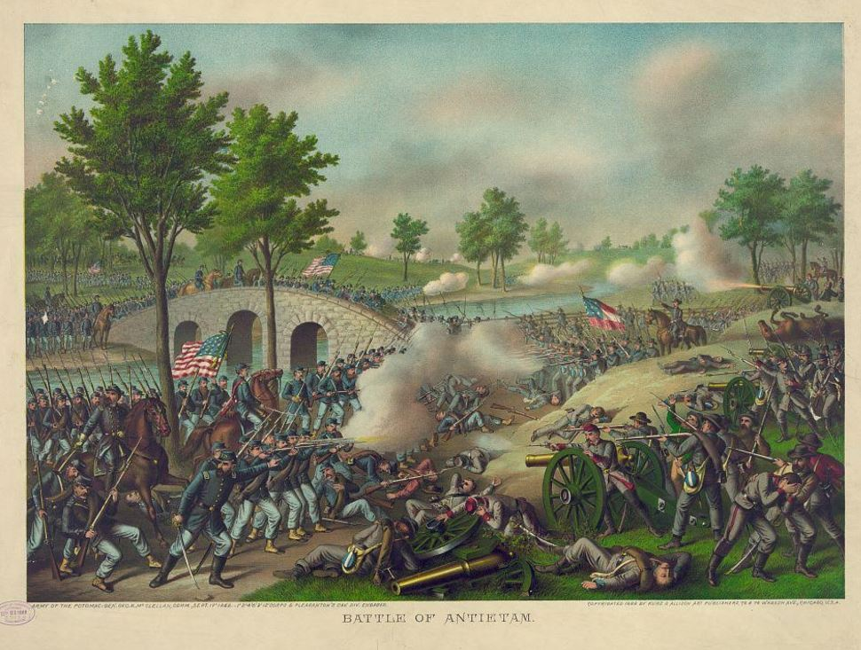
Vicksburg
A primary objective of the Union forces in the Civil War was to cut the Confederacy in two by winning control of the Mississippi River. To do this it was necessary to take the Confederate stronghold at Vicksburg, Mississippi. As long as Vicksburg was held by the South, Union vessels could not operate freely on the river. The city also served as an important transportation point for the Confederacy. Supplies, arms, and men from the southwestern states were assembled at Vicksburg and then transported eastward by rail.
On Jan. 29, 1863, General Ulysses S. Grant was put in command of the Army of the West, with orders to capture Vicksburg. It was a difficult assignment because the city, located east of the Mississippi, was on a high bluff overlooking a hairpin bend in the river. All earlier attacks against Vicksburg had failed. Grant now set his men to work with pick and shovel rather than with guns. They tried to dig a canal across the neck of land opposite the city and thus bypass Vicksburg by turning the river from its old bed. Despite their most strenuous efforts Grant's troops failed to change the course of the river. Another way to reach the city had to be found. Grant saw that Vicksburg could be approached only from the south and east.
The west bank of the Mississippi became dry enough for the men to travel over, but how were they to recross to the east bank after getting below the city? This could be done in only one way: The Union fleet would have to face the Confederate batteries and go down the stream as the men marched along the west shore. One dark night the attempt was made. The Confederates learned of the plan and sent troops across the river in skiffs. They set fire to houses on the shore so that Confederate gunners might have light to see the Union ships. Nevertheless all but one of the Union's vessels ran by the batteries in safety and transported Grant's men to the eastern bank.
This was all accomplished by the end of April 1863. Now began the task of pushing the Confederate troops back into the city. Seven times Grant met and defeated them before he reached Vicksburg. Failing to take the town by storm, he settled down to starve it into surrender. For seven weeks the town held out.
Supplies ran low and were rationed. Horses and mules were killed for meat. Men died of disease and starvation. When Gen. John Pemberton finally asked what terms would be given them, Grant replied: "Unconditional surrender." Pemberton was forced to accept these hard terms on July 4, 1863. This major victory at the Battle of Vicksburg gave the Union control of the Mississippi River and thus split the Confederacy in half.

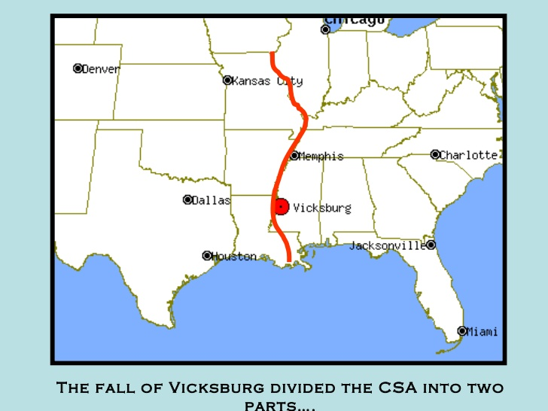
Gettysburg
Undaunted by his first failed invasion of the North at the Battle of Antietam, General Robert E. Lee marched into Northern territory again in the summer of 1863, this time into Pennsylvania. On July 1, the advancing Confederates clashed with the Union’s Army of the Potomac, commanded by General George G. Meade, at the crossroads town of Gettysburg. The next day saw even heavier fighting, as the Confederates attacked the Federals on both left and right. On July 3, Lee ordered an attack by fewer than 15,000 troops on the enemy’s center at Cemetery Ridge. The assault, known as “Pickett’s Charge,” managed to pierce the Union lines but eventually failed, at the cost of thousands of rebel casualties, and Lee was forced to withdraw his battered army toward Virginia on July 4. At the end of a bloody three-day struggle in which more than 50,000 died, Lee was once again forced to retreat. The battle was a resounding victory for the North and a catastrophe for the South.
The Battle of Gettysburg was the turning point of the Civil War. After failing at Gettysburg, the Confederate troops were on the defensive the rest of the war and the tide had turned permanently against the South.

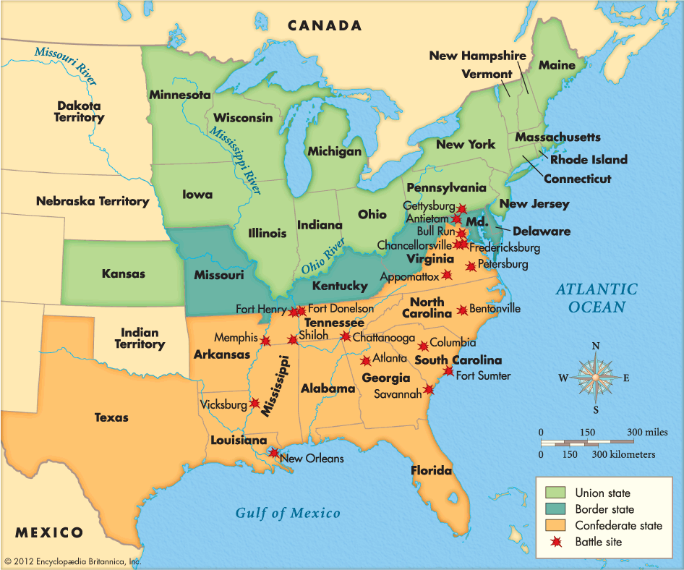

Atlanta and the March to the Sea
President Abraham Lincoln and General Ulysses S. Grant chose to step up the war in 1864 after realizing that limited campaigns against Confederate forces were having little effect. Both knew that the war had to end quickly if the Union were to be restored. Grant therefore ordered his close friend and fellow general William Tecumseh Sherman to take a small force through the heart of the Deep South. That summer, Sherman embarked on his now-famous March to the Sea, defeated Confederate troops protecting Atlanta, Georgia, and then besieged the city. When the citizens of Atlanta failed to surrender, Sherman burned the city and then marched on to Savannah. Along the way, he destroyed railroads, burned homes, razed crops, and generally looted and pillaged the entire countryside—one witness said a tornado could not have done more damage. Sherman believed that the Confederacy derived its strength not from its fighting forces but from the material and moral support of sympathetic Southern whites. Factories, farms and railroads provided Confederate troops with the things they needed, he reasoned; and if he could destroy those things, the Confederate war effort would collapse. Meanwhile, his troops could undermine Southern morale by making life so unpleasant for Georgia’s civilians that they would demand an end to the war. Sherman arrived in Savannah that December and accepted the city’s surrender, then marched northward to South Carolina.
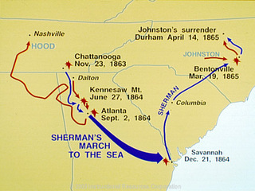
Appomattox Court House
In April 1865, Ulysses S. Grant’s forces broke through Robert E. Lee’s defenses and forced the Confederates to retreat. The Confederate forces burned their capital city, Richmond, behind them as they retreated in order to render it useless to the Union armies. His men malnourished and heavily outgunned, Lee chose to surrender. Several days later, on April 9, 1865, Lee surrendered to Grant formally and unconditionally at Appomattox Courthouse, Virginia. Generously, all officers and men were to be pardoned, and they would be sent home with their private property–most important to the men were the horses, which could be used for a late spring planting. Officers would keep their side arms, and Lee’s starving men would be given Union rations.
Quieting a band that had begun to play in celebration, Grant told his officers, “The war is over. The Rebels are our countrymen again.” Although scattered resistance continued for several weeks—the final skirmish of the Civil War occurred on May 12 and 13 at the Battle of Palmito Ranch near Brownsville, Texas—for all practical purposes the Civil War had come to an end.

