Abraham Lincoln
Abraham Lincoln, a self-taught lawyer, legislator and vocal opponent of slavery, was elected 16th president of the United States in November 1860, shortly before the outbreak of the Civil War. Lincoln proved to be a shrewd military strategist and a savvy leader. From the outset of the Civil War, Lincoln’s primary goal was to preserve the Union (United States) stating, “If I could save the Union without freeing any slave I would do it, and if I could save it by freeing all slaves I would do it.” His Emancipation Proclamation paved the way for slavery’s abolition, while his Gettysburg Address stands as one of the most famous speeches in American history. In April 1865, with the Union on the brink of victory, Abraham Lincoln was assassinated by Confederate sympathizer John Wilkes Booth; his untimely death made him a martyr to the cause of liberty, and he is widely regarded as one of the greatest presidents in U.S. history.
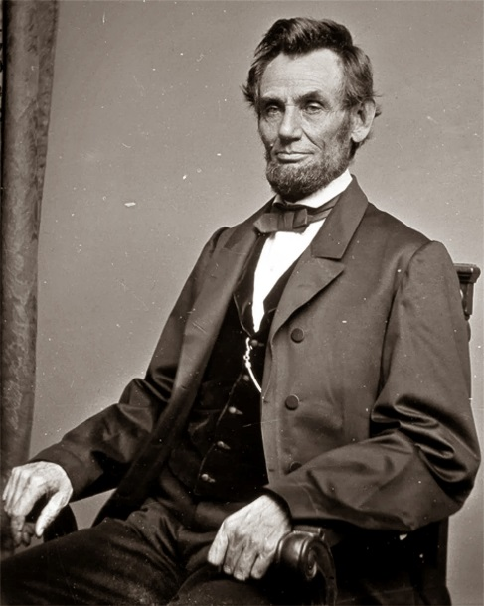
Jefferson Davis
Jefferson Davis (1808-1889) was a Mexican War hero, U.S. senator from Mississippi, U.S. secretary of war, and president of the Confederate States of America for the duration of the American Civil War (1861-1865). Prior to the start of the war, Davis had argued against secession, but when Mississippi seceded he resigned from the U.S. Senate. In February 1861 he was elected president of the Confederacy. Davis faced difficulties throughout the war as he struggled to manage the Southern war effort, maintain control the Confederate economy and keep a new nation united. Davis’ often contentious (argumentative) personality led to conflicts with other politicians as well as his own military officers. In May 1865, several weeks after the Confederate surrender, Davis was captured, imprisoned and charged with treason, but never tried and was released after two years.
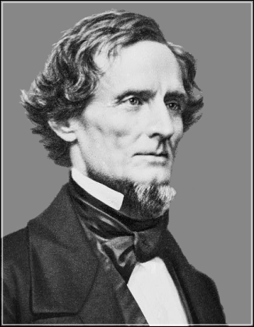
Ulysses S. Grant
Ulysses Grant (1822-1885) commanded the victorious Union army during the American Civil War (1861-1865) and later served as the 18th U.S. president from 1869 to 1877. An Ohio native, Grant graduated from West Point and fought in the Mexican-American War (1846-1848). During the Civil War, Grant, an aggressive and determined leader, was given command of all the U.S. armies. Grant commanded troops at the Battle of Shiloh, which, because it was such a costly battle, solidified his role as a great leader. He also commanded troops at the siege of Vicksburg, the battle of Chattanooga, and the Siege of Petersburg. On April 9th, 1865 Confederate General-in-chief Robert E. Lee surrendered to Grant at Appomattox Court House, effectively ending the Civil War. After the war he became a national hero, and the Republicans nominated him for president in 1868.
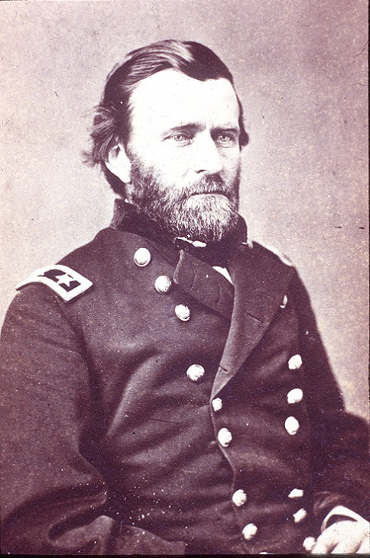
Robert E. Lee
Robert E. Lee (1807-70) served as a military officer in the U.S. Army, a West Point commandant, and the legendary general-in-chief of the Confederate Army during the American Civil War (1861-65). In June 1861, Lee assumed command of the Army of Northern Virginia, which he would lead for the rest of the war. Lee and his army achieved great success during the Peninsula Campaign and at Second Bull Run (Mansassas) and Fredericksburg, with his greatest victory coming in the bloody Battle of Chancellorsville. In the spring of 1863, Lee invaded the North, only to be defeated at the Battle of Gettysburg. With Confederate defeat a near certainty, Lee continued on, battling Union General Ulysses S. Grant in a series of clashes in Virginia in 1864-65 before finally surrendering what was left of his army in April 1865. Lee has been praised by many for his tactical brilliance, and remains a revered figure in the American South.
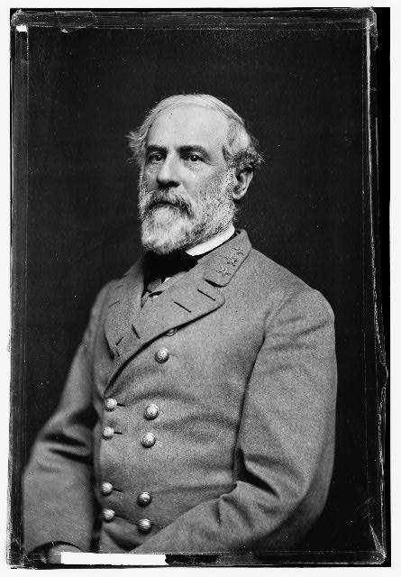
William T. Sherman
Perhaps the originator and the first practitioner of what the twentieth century came to know as “total war,” William Tecumseh Sherman in 1864 commanded the Union armies of the West in the decisive drive from Chattanooga to Atlanta and the famous “march to the sea” across Georgia. General Sherman’s troops captured Atlanta on September 2, 1864. This was an important triumph, because Atlanta was a railroad hub and the industrial center of the Confederacy: It had munitions factories, foundries and warehouses that kept the Confederate army supplied with food, weapons and other goods. It was also a symbol of Confederate pride and strength, and its fall made even the most loyal Southerners doubt that they could win the war. After conquering Atlanta, Sherman and his army marched on to Savannah, carrying the war to the Southern home front and blazed a wide path of destruction that delivered the death blow to the Confederacy’s will and ability to fight. For the accompanying destruction, his name is still cursed in some parts of the South; but he is also recognized as a great strategist, a forceful leader, and–together with Ulysses Grant –the ablest Union general of the war.
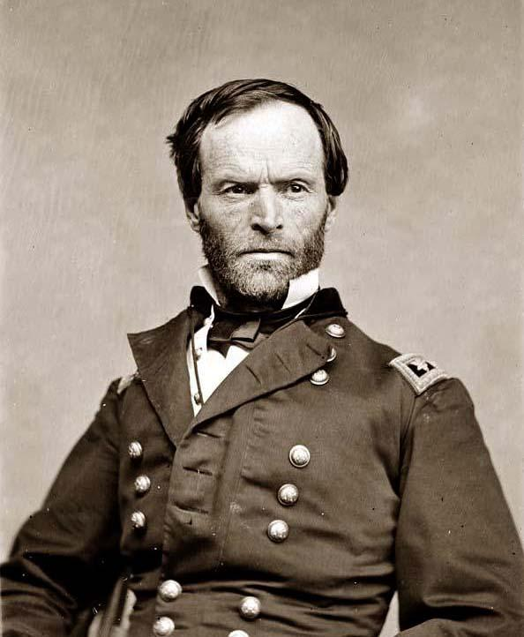

Stonewall Jackson
Thomas “Stonewall” Jackson (1824-63) was a war hero and one of the South’s most successful generals during the American Civil War (1861-65). After a difficult childhood, he graduated from the U.S. Military Academy at West Point, New York, in time to fight in the Mexican-American War (1846-48). He then left the military to pursue a teaching career. After his home state of Virginia seceded from the Union in 1861, Jackson joined the Confederate army and quickly forged his reputation for fearlessness and tenacity during the Shenandoah Valley Campaign later that same year. He served under General Robert E. Lee (1807-70) for much of the Civil War. Jackson was a decisive factor in many significant battles such as the First and Second Battles of Bull Run and the Battle of Antietam. Jackson was mortally wounded by friendly fire at the age of 39 during the Battle of Chancellorsville in May 1863. His left arm was amputated in an attempt to save his life, but Jackson died from pneumonia 8 days later. General Robert E. Lee remarked before Jackson’s death, “[Stonewall] has lost his left arm, but I have lost my right arm.”
