FDR’s Court Packing Plan
Supreme Court opposition to Roosevelt’s programs continued with the Court consistently vetoing New Deal legislation. FDR asked Congress to approve a law that would permit the President to increase the number of Supreme Court judges from nine to fifteen if the judges refused to retire by the age of 70. The Judiciary Reorganization Act of 1937 – or “court packing plan” as opponents called it – was intended to make the Supreme Court approve New Deal laws. It never became a law because it threatened the separation of powers.

1. How many judges are on the Supreme Court? How long do they serve for? Who appoints them?

2. What was the Judiciary Reorganization Act?

3. Why did FDR want to change the number of Supreme Court judges?

4. Why did this bill never become a law?

5. Answer the following based on the cartoon below:

a. Who are the men on the right?

b. What is FDR doing?
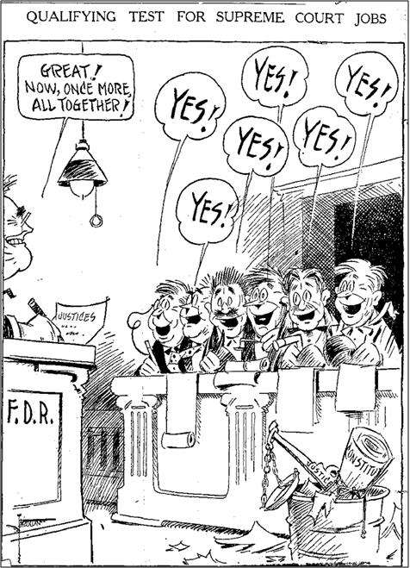

c. Explain what’s in the garbage and why.

d. What is the main idea of the cartoon?

