- Following the Civil War and Reconstruction (1861-1877), the United States experienced a phase of rapid industrialization
  - Mechanization of labor in factories = machines mass producing consumer goods
  - Population transitions from rural settlements to cities = urbanization
- This period is known as the ____________________ and lasted from 1870-1900.
  - Why did Mark Twain call this period the Gilded Age?
Gilded Age Inventions/Innovations
- America’s industrial revolution began with a wave of new inventions
  - _______________, _______________, _______________ made businesses more efficient
  - Guglielmo Marconi’s _______________ and Alexander Graham Bell’s _______________ revolutionized communication
  - ____________________ created a cheap way to transform iron into stronger, lighter steel
    - Steel was the dominant building material of the Gilded Age
Thomas Edison
- Thomas Edison was the greatest inventor of the 1800’s
- His inventions included:

Railroads
- America’s first “big business” were the ____________________
- Large companies bought small railroads, standardized gauges and schedules, and pooled cars
- As railroads expanded, so did the rest of the U.S. economy
- The 1st ____________________________ was finished in 1869
- Railroads stimulated demand for __________, __________, __________, and __________
Steel
- Lighter and stronger than iron, steel was essential for the construction of

Tycoons of the Gilded Age: Robber Barons or Captains of Industry?
- Cornelius Vanderbilt

- Andrew Carnegie
  - Dominated the __________ and __________ industries during the Gilded Age
  - Carnegie made high quality steel at the lowest price by adopting the ____________________ in his steel mills
  - Carnegie Steel produced more steel than all of the steel factories in Great Britain combined
  - How did Carnegie represent the American dream?

Was Andrew Carnegie a Robber Baron or a Captain of Industry?
Robber Baron | Captain of Industry

- John D. Rockefeller
  - Industrialization led to a demand for oil for ______________________________
  - Rockefeller’s company, ________________________, dominated the oil industry during the Gilded Age
  - Rockefeller used ruthless business tactics to buy out competing companies and eliminate all competition
  - By 1879, Standard Oil controlled ______________ of the oil in America = Monopoly

Was John D. Rockefeller a Robber Baron or a Captain of Industry?
Robber Baron | Captain of Industry

- J.P Morgan

New Forms of Business Organization
- In the 17th and 18th centuries, goods were produced by families out of their homes = “Cottage Industries”

- Beginning in the 19th century, manufacturing transitioned to small, individually owned factories

- During the Gilded Age, massive corporations, with multiple owners sharing the risk and profit, replaced small family businesses

- Vanderbilt, Carnegie, and Rockefeller changed the way businesses were organized
  - Trusts:

  - Holding Companies:

Methods of Consolidation
- Horizontal Integration:
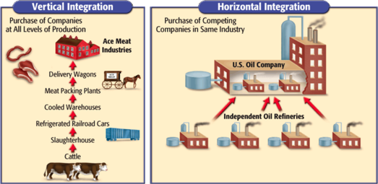

- Vertical Integration:

- The merging of businesses through vertical and horizontal integration led to giant companies called _____________________, which controlled the majority of an industry
  - Example of monopolies include Rockefeller’s Standard Oil and Carnegie’s Carnegie Steel
- Monopolies became known as ____________________, because they were often ran by a board of trustees

- Monopolists justified their wealth in a variety of ways:
  - “Gospel of Wealth”:

  - Social Darwinism :

- During the Gilded Age, the U.S. government practiced a “laissez-fair” policy that benefited large corporations
- Define laissez-fair economics:

