Franklin D. Roosevelt on “Court-Packing”
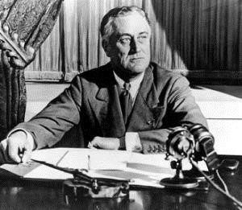
Toward the end of Franklin D. Roosevelt’s first administration, the Supreme Court began to declare important New Deal legislation, such as the National Industrial Recovery Act, unconstitutional. In 1937 Roosevelt introduced legislation designed to change the makeup of the Court. Roosevelt’s proposal would empower the president to appoint a new member whenever an incumbent justice, who had been acting as a judge for at least ten years, failed to retire at the age of seventy; most conservatives on the Supreme Court were already over seventy. The maximum number of justices would be set at fifteen, six more than the court consisted of. Here is part of the President’s explanation of this bill.
When I commenced to review the situation with the
problem squarely before me, I came by a process of elimination to the conclusion that, short of amendments, the only method which was clearly constitutional, and would at the same time carry out other much needed reforms, was to infuse new blood into all our Courts. We must have men worthy and equipped to carry out impartial justice. But, at the same time, we must have Judges who will bring to the Courts a present-day sense of the Constitution - Judges who will retain in the Courts the judicial functions of a court, and reject the legislative powers which the courts have today assumed… What is my proposal? It is simply this: whenever a Judge or Justice of any Federal Court has reached the age of seventy and does not avail himself of the opportunity to retire on a pension, a new member shall be appointed by the President then in office, with the approval, as required by the Constitution, of the Senate of the United States. That plan has two chief purposes. By bringing into the judicial system a steady and continuing stream of new and younger blood, I hope, first, to make the administration of all Federal justice speedier and, therefore, less costly; secondly, to bring to the decision of social and economic problems younger men who have had personal experience and contact with modern facts and circumstances under which average men have to live and work. This plan will save our national Constitution from hardening of the judicial arteries.
- Franklin D. Roosevelt Fireside Chat, March 9, 1937

Questions
- What does Roosevelt give here as his reasons for presenting this bill?

- What do you think were his real reasons?

- What flaws can you find in his arguments?

- The president’s bill was referred to the Committee on the Judiciary. How do you think they responded to it?

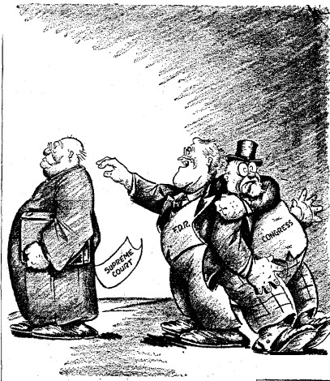
Court-Packing in Political Cartoons Let’s Harmonize
- How is FDR treating Congress?

- Why is FDR reaching toward the Supreme Court?

- According to the cartoonist, which branch of government is trying to dominate?

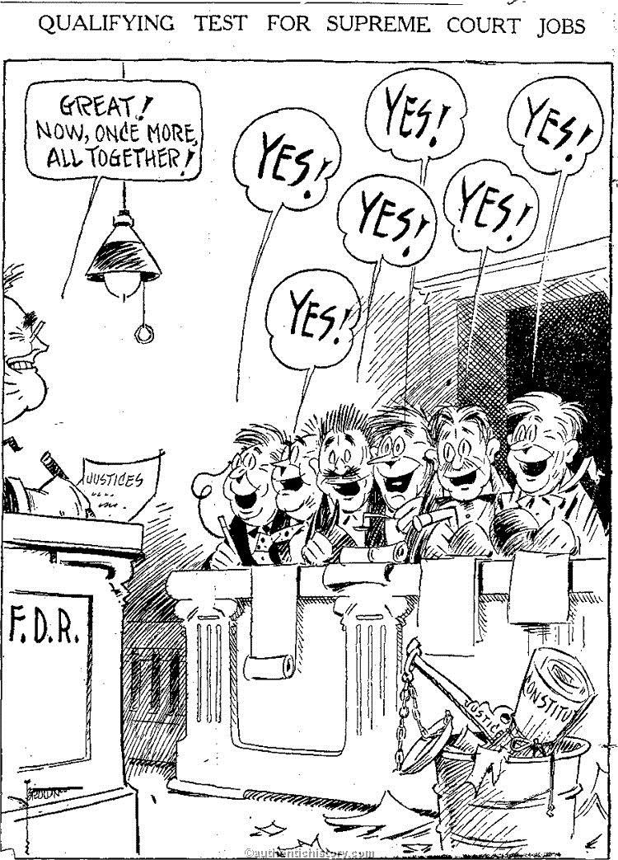

Qualifying Test
- According to this cartoon, what is the answer to the “test” to get on the Supreme Court under FDR’s plan?

- What is in the trash bucket in the right corner of the picture?

- What is the cartoonist saying by placing these items in the trash?

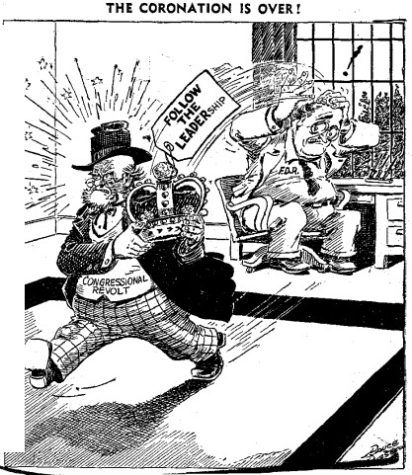
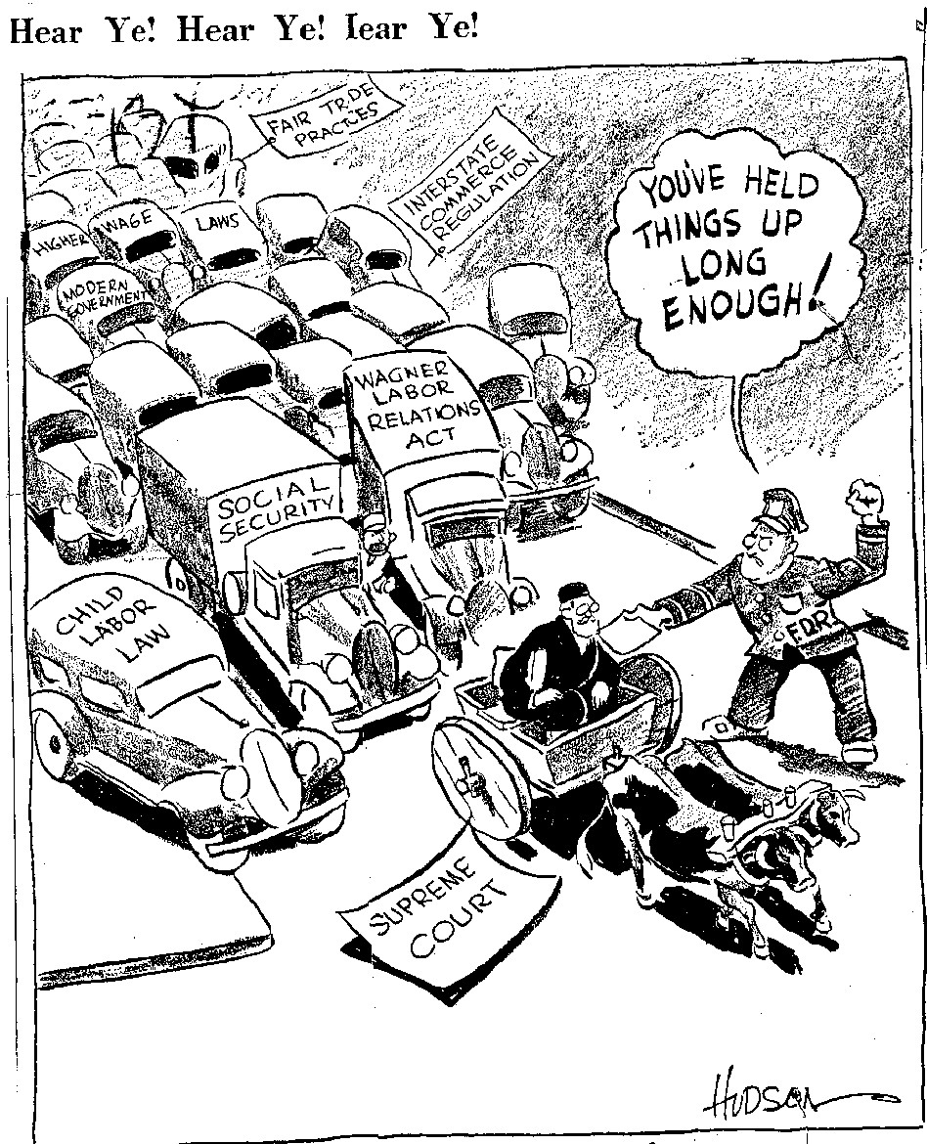
“Coronation is Over”
- What does the man carrying the crown symbolize?

- How is Congress changing its behavior?

- Why did Congress change its attitude toward the President?

“Hear Ye! Hear Ye! Hear Ye!”
- What is the Supreme Court driving in this cartoon?

- What is used to symbolize the New Deal legislation?

- What is the cartoonist’s message by using these two different forms of transportation?

- How is this cartoon different than the previous three?

