AP U.S. History
Mr. Willis

Period 5 Study Guide: Road to Civil War, Civil War and Reconstruction
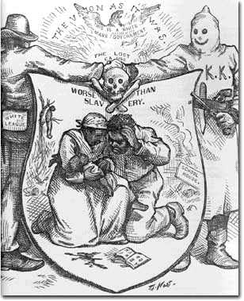
Essential Questions:
- How did sectionalism become more important than nationalism?
- Was the Civil War inevitable?
- Why was the Election of 1860 the final straw that led to secession?
- What were South Carolina’s reasons for seceding? How did Lincoln respond to them in his 1st inaugural address?
- What were the major advantages and disadvantages for the Union and the Confederacy at the start of the Civil War?
- What were the Union and Confederate war strategies?
- Why did Lincoln issue the Emancipation Proclamation?
- How did Lincoln’s view of the Civil War change and alter with time?
- What major issues needed to be resolved after the Civil War regarding…
- Southern states and ex-Confederate officers?
- The Southern economy
- Black freedmen
- What were the different “phases” of Reconstruction and why did the shifts occur?
- How did Reconstruction end? What was the legacy of that conclusion?
- *Should Reconstruction be considered a success or failure?
ID Terms:
Read each assignment carefully & identify the ID terms below in your own words. These will serve as excellent study tools for your quiz. For each ID term, make sure you are able to A) define/describe and B) explain why it is historically significant.
ID Terms
Manifest Destiny  Review Southern social classes pyramid  Missouri Compromise  Texas Independence  Remember the Alamo!  Mexican-American War  Treaty of Guadalupe-Hidalgo  James K. Polk  Compromise of 1850  Fugitive Slave Law  Popular sovereignty  Uncle Tom’s Cabin/Harriett Beecher Stowe  Kansas Nebraska Act  Stephen Douglass  Bleeding-Kansas  Border Ruffians  Caning of Charles Sumner  Dred Scott  Lincoln-Douglass debates  John Brown’s raid  Election of 1860  Anaconda Plan  Fort Sumter  Jefferson Davis  Robert E. Lee  George McClellan  Stonewall Jackson  Ulysses S. Grant  First Battle of Bull Run  Antietam | Emancipation Proclamation  Draft Riots  Writ of Habeas Corpus  Siege of Vicksburg  Battle of Gettysburg  Gettysburg Address  Election of 1864  Appomattox Court House  “Reconstruction issues”  Lincoln’s 10% plan  Radical Republicans  Wade-Davis Bill  Civil Rights Act of 1866  Freedman’s Bureau  Military Reconstruction Act  Scalawags  Carpetbaggers  Integration/segregation  Redeemers  Compromise of 1877  Jim Crow laws  Vagrancy Laws  Poll tax  Literacy tests  Grandfather clauses  Andrew Johnson: views, impeachment trial  Black codes  13th, 14th, 15th Amendments  Sharecropping  Tenant farming  Ku Klux Klan & KKK acts

