The period in U.S. History immediately following the Civil War is referred to as _______________
What were the major questions/goals of Reconstruction?

President Abraham Lincoln and President Andrew Johnson favored a Reconstruction plan that would show the South __________ and quickly bring the seceded states back into the Union
The Radical Republicans that controlled Congress after the Civil War wanted a Reconstruction plan that would ___________ the South for the war and set strict
Reconstruction Plans
Lincoln’s Plan: The 10% Plan (Never implemented) | Johnson’s Plan: Presidential Reconstruction  (1865-1867) | Radical Republicans’ Plan: Congressional Reconstruction (1867-1877)
Republican Response to Lincoln’s Plan: Wade-Davis Bill
The Reconstruction Amendments
13th Amendment (1865):

14th Amendment (1868):

15th Amendment (1870):
Congressional Efforts to Aid Former Slaves
Freedmen’s Bureau (1865-1872):

Southern Resistance During Presidential Reconstruction (1865-1867)
During the first phase of Reconstruction, under President Johnson’s lenient plan, former Confederate leaders were pardoned and returned to positions of authority in the southern states. They quickly instituted laws to limit African-American rights
Black Codes:

Ku Klux Klan:
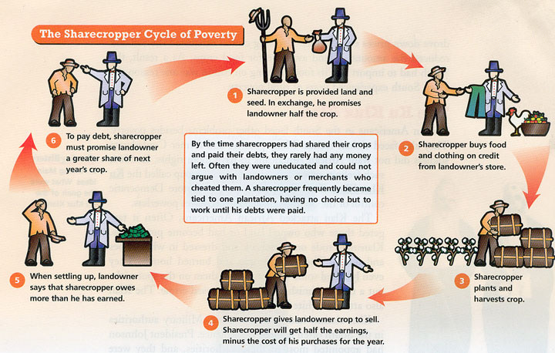

Sharecropping:

Johnson vs. Congress
President Johnson’s was a white supremacist who vetoed Republican programs such as the Freedmen’s Bureau and encouraged southern states not to ratify the 14th Amendment. Congress took over Reconstruction in 1867 (beginning of Congressional Reconstruction Period) and attempted to remove Andrew Johnson from office so he could no longer interfere with their Reconstruction plan.
Civil Rights Act of 1866:

14th Amendment:

Military Reconstruction Act of 1867:

New terms for readmission to the Union:

Johnson Impeached
Tenure of Office Act:

Impeachment of Andrew Johnson:

Achievements Under Congressional Reconstruction
Republican Party Dominates in South
- Freedmen

- Carpetbaggers

- Scalawags
15th Amendment/African American Enfranchisement

End of Reconstruction
Election of 1868:

Norths “waning interest” with Reconstruction:
Corruption within President Ulysses S. Grant’s administration and an economic depression known as the Panic of 1873 distracted the nation from enforcing Reconstruction. Enforcement was expensive and by 1870, Congress and President Grant were unwilling to use the federal government to monitor southern society.

“Redeemer” Democrats Seize Power:

Election of 1876:

Compromise of 1877:

After Reconstruction…
Jim Crow Laws:

Poll Taxes:

Literacy Tests:

Grandfather Clause:

Successes and Failures of Reconstruction?

