Outbreak of WWII
- In the years following WWI (1914-1918), a global economic depression devastated the economies of the world’s major industrial nations, causing social unrest and political instability and opening the door for totalitarian dictators to seize power
  - Totalitarianism is a system of government in which all aspects of public and private life are government controlled. Rulers of totalitarian governments are absolute dictators not bound by constitutions or laws.
- A new form of totalitarianism, fascism, rose to prominence in several European nations in the aftermath of WWI
  - Fascism emphasized complete loyalty to the state (nation more important than individual), extreme nationalism (superiority of your nation/ethnic group), militarism, territorial expansion, loyalty to authoritarian leader, single political party, etc.
- In 1925, Benito Mussolini became sole dictator of Italy, instituting a fascist regime
- In 1933, Adolf Hitler and the Nazi Party took control of Germany, instituting a fascist regime
- During the 1930’s, military elites, led by General Hideki Tojo, ruled Japan, with the Emperor as a powerless figurehead
- Hitler openly defied the Treaty of Versailles (treaty that ended WWI) by rebuilding the Germany military, annexing Austria in 1938, and invading Czechoslovakia in 1939
- Under Mussolini, Italy invaded and conquered Ethiopia in 1935
- Japan invaded Manchuria in 1931 and mainland China in 1937
- While the Axis Powers became increasingly aggressive, invading more and more territory, Britain and France followed a policy of appeasement, allowing Germany, Italy, and Japan to take territory with no response/consequence in order to avoid another war
- At the Munich Conference of 1938, England (Neville Chamberlain), France (Edouard Daladier), and Italy (Benito Mussolini) agreed that Germany could annex the Sudetenland (part of Czechoslovakia) and Hitler agrees not to invade the rest of Czechoslovakia… (Spoiler Alert! Hitler invades the rest of Czechoslovakia less than a year later)
- On September 1, 1939 Germany invaded Poland, an ally of Britain and France, starting the Second World War
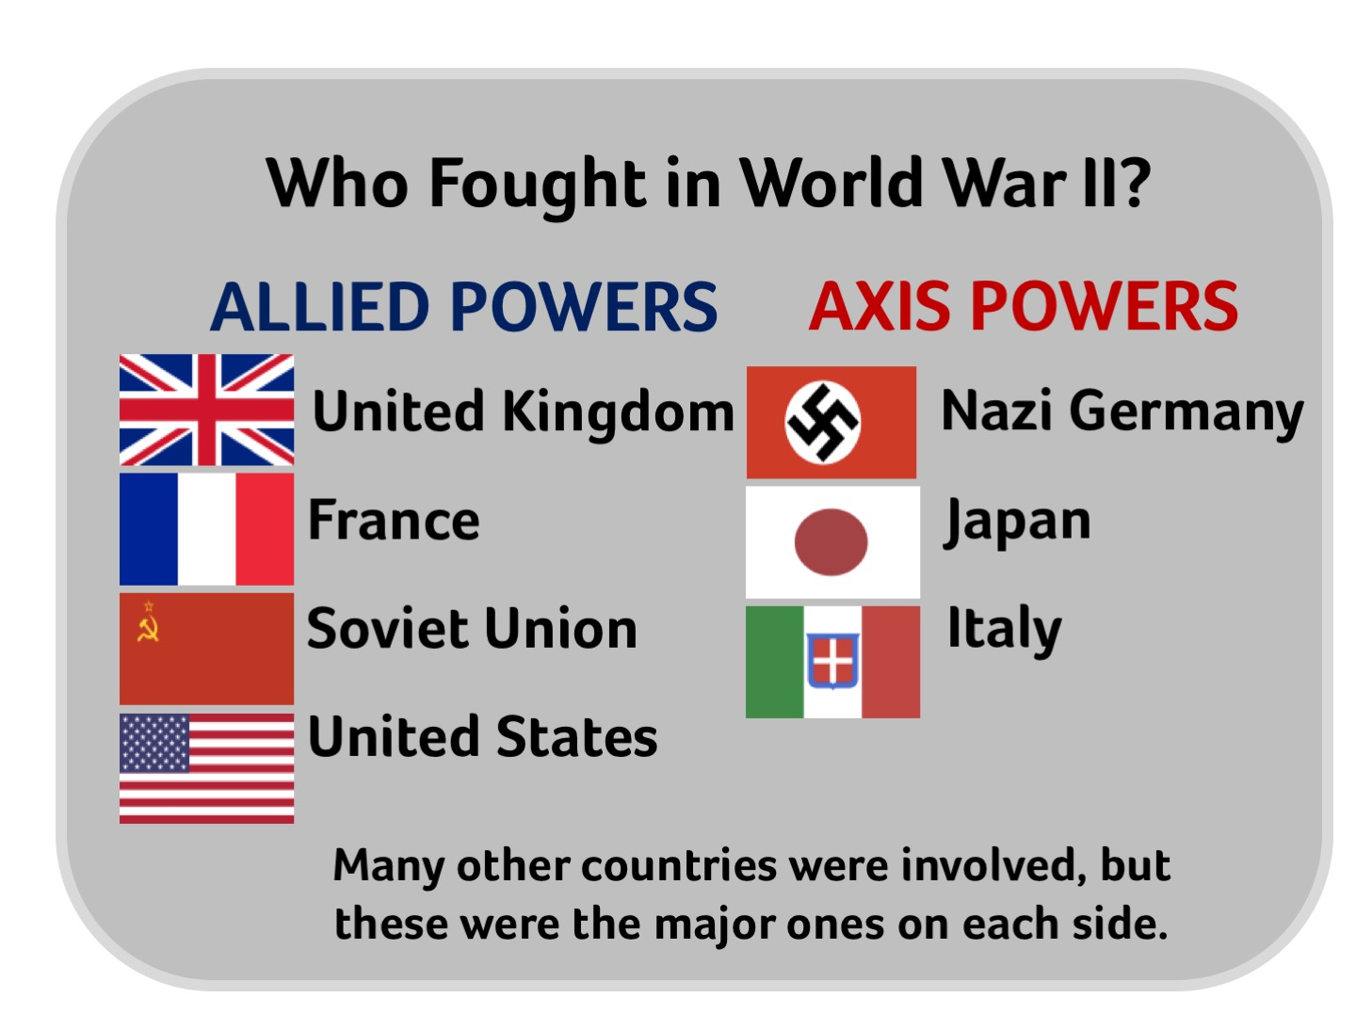
U.S. Neutrality
- Germany quickly invaded and conquered France in 1940, using the Blitzkrieg (lightning-war) strategy, leaving Great Britain as the only nation resisting Nazi domination of Europe (Germany and the Soviet Union had agreed upon a non-aggression pact in 1939) *Germany would later break this agreement and invade the USSR in 1941
- As the war raged in Europe, the United States pursued an official policy of neutrality, as it had at the start of WWI
- To ensure the United States remained out of WWII, Congress passed the Neutrality Acts (1935-1937), making it illegal to sell weapons or loan money to nations involved in the war or for Americans to travel on ships of countries involved in the conflict
- With pressure from FDR, Congress passed the Neutrality Act of 1939, which revised the previous acts by allowing the US to provide military aid to its allies on a cash and carry basis, meaning those nations were required to pay for the supplies up front and transport them on their own ships
- Although the US was still officially neutral, in 1941 Congress passed the Lend-Lease Act, giving President Roosevelt the power to lend/lease and transport military aid to US allies, such as Britain and China, if he deemed it necessary (they were no longer required to pay for the materials immediately or transport the supplies themselves)
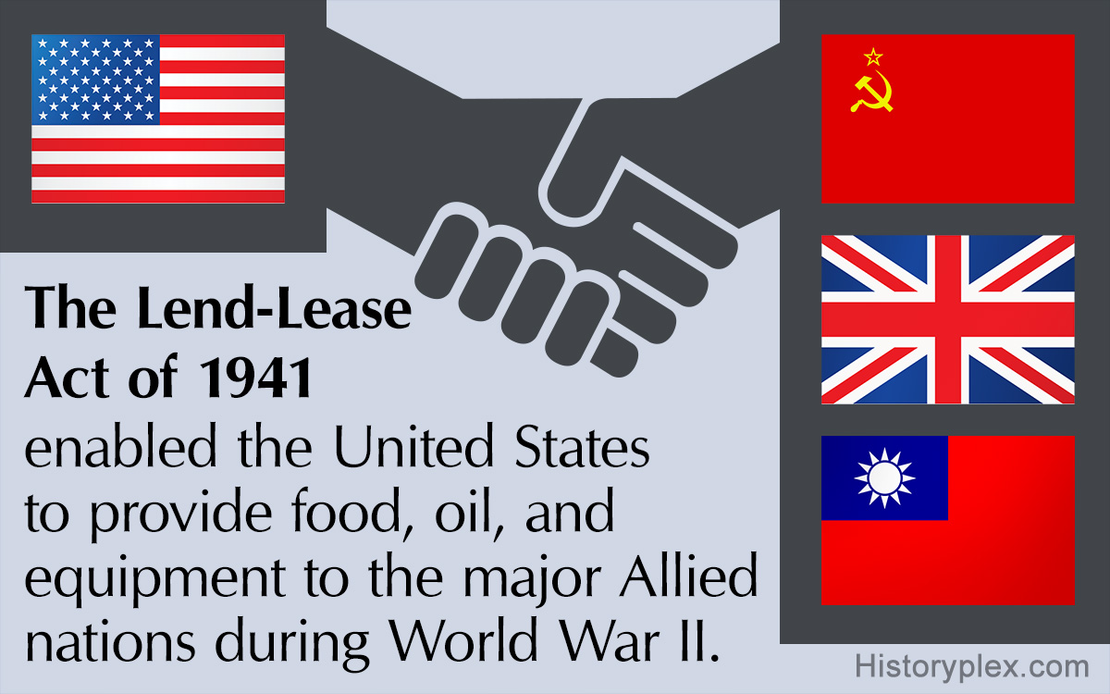

US Enters WWII
- In July 1941, the US placed an embargo on oil exports to Japan, in an attempt to discourage Japanese aggression in the Pacific (Japan had continued its invasion of China and invaded Vietnam in Sept. 1940)
- Japan, fearing that the US might interfere with their plans for territorial expansion in Asia, planned to neutralize the U.S, Pacific fleet stationed at Pearl Harbor, Hawaii
- On December 7, 1941, the Japanese attacked Pearl Harbor, where they managed to destroy or damage nearly 20 American naval vessels, including eight battleships, and over 300 airplanes. More than 2,400 Americans died in the attack, including civilians, and another 1,000 people were wounded.
- The following day, President Roosevelt asked Congress for a declaration of war on Japan, marking the official entry of the U.S. into WWII

European Theater of WWII
- WWII was fought in two major theaters (area in which important military events are occuring)
  - European theater: The war in Europe: Allies vs. Germany and Italy
  - Pacific theater: The war in Asia and the Pacific Ocean: Allies vs. Japan
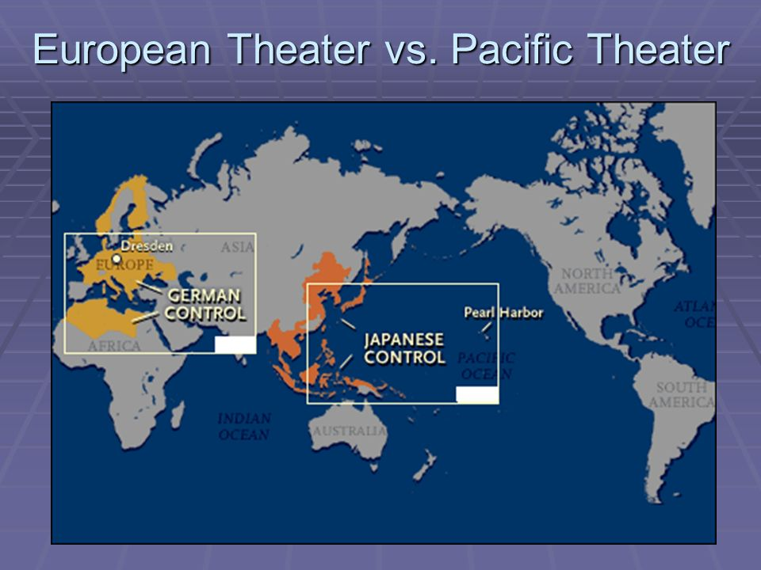
- The most significant military operation in the European Theater of WWII was the D-Day Invasion/Invasion of Normandy, France (Codenamed “Operation Overlord”)
- On June 6, 1944 a combined force of 156,000 American, British, and Canadian troops sailed from England to the northern coast of France (Normandy) and invaded the French beaches in an attempt to liberate France from Nazi control
- Over the following months, the British and American forces fought there way into Germany from the West, while the Soviet Union’s “Red Army” invaded Germany from the East
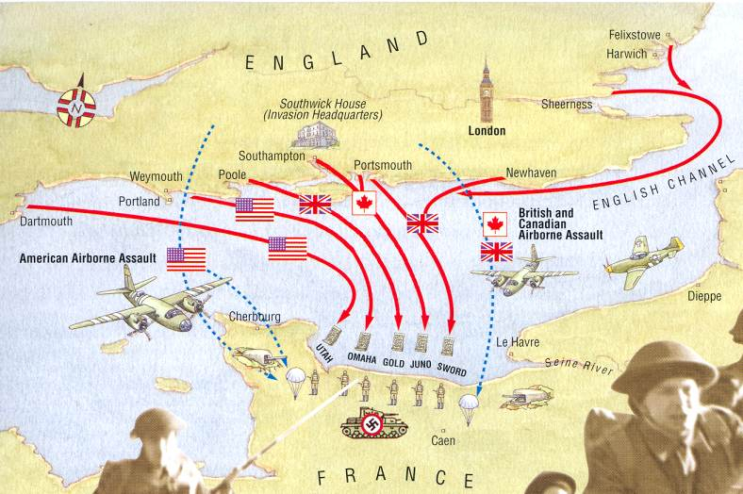
- The Battle of Berlin was the final battle in the European Theater of WWII. In April 1945 the Soviet Union’s Red Army reached the German capital city and forced the city to surrender on May 2, 1945
- V-E Day (Victory in Europe Day) = Day of Germany’s formal surrender to the Allies on May 8, 1945
- Although, Germany and Italy had been defeated in Europe, the U.S. was still battling Japan in the Pacific Theater of the war

Pacific Theater of WWII
- Following the Japanese attack on Pearl Harbor, Japan seized much of the land in the South Pacific, including American territories such as the Philippines and Guam
- The U.S. military strategy in the Pacific Theater was known as island hopping
  - U.S. forces moved from island to island, defeating the Japanese on each island and then using each as a base for capturing the next
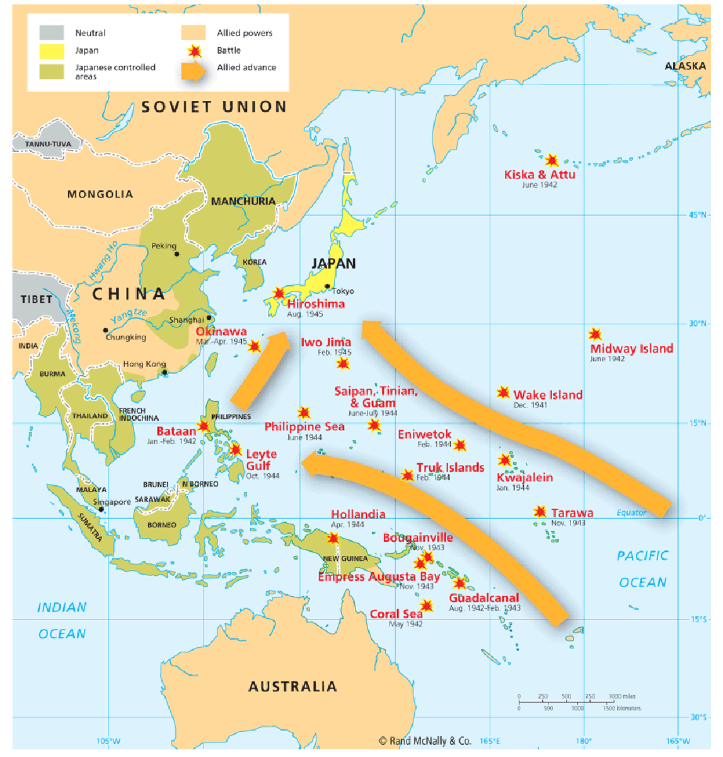
- The turning point in the Pacific Theater was the Battle of Midway in June 1942
  - The Japanese tried to trap and sink America's aircraft carriers near Midway Island, which was an American refueling station for ships and airplanes. The United States had gained intelligence information that the attack was coming and lured the Japanese into the waiting American forces. In the Battle at Midway, the United States destroyed four Japanese aircraft carriers while losing only one American carrier. The Japanese never recovered from this defeat, which enabled the United States to gain control of other strategic Pacific Islands.
- The Pacific Theater presented unique challenges for the United States in delivering food, weapons, and medical supplies to troops in the region during World War II
- By August 1945, the U.S. had successfully positioned themselves for an assault of the Japanese mainland through the island hopping strategy
- Japan refused to surrender in July 1945 and defeating Japan would have necessitated a massive invasion by U.S. forces, which the US government estimated would have cost millions of American lives
- Instead, President Harry S. Truman (took over after FDR died in April 1945) opted to use the newly developed atomic bombs to force Japan into surrender
- On August 6, 1945 the US dropped the atomic bomb, Little Boy, on the city of Hiroshima, Japan
- On August 9, 1945, the U.S. dropped a second atomic bomb, Fat Man, on Nagasaki, Japan, resulting in the surrender of Japan
- August 14, 1945 is known as V-J Day (Victory in Japan Day)
- The bombings of Hiroshima and Nagasaki resulted in the deaths of 150,000-200,000 people, the majority of them civilians

WWII on the Homefront
- WWII was a total war, necessitating the mobilization of U.S. civilians and industry by the government to support the war effort in Europe and the Pacific
- The U.S. government encouraged Americans to contribute to the war effort by:
  - Buying war bonds: purchasing government issued bonds, thereby providing the government with quick cash to fund the war effort
  - Rationing: War ration books and tokens were issued to each American family, dictating how much gasoline, tires, sugar, meat, silk, shoes, nylon and other items any one person could buy in order to preserve essential supplies for the war effort
  - Planting Victory Gardens: to preserve food supply for the military
  - Participating in scrap drives: recycling materials such as rubber and metals so they could be used for war materials
- Women and WWII
  - Women served in the military as nurses, drove trucks, repaired planes, performed clerical work
  - Women were essential in filling factory jobs during WWII, manufacturing munitions, building tanks, planes, ships, and other war materials
  - “Rosie the Riveter” was a propaganda symbol created by the US gov. to encourage women to join the workforce
- African Americans and WWII
  - On the homefront, African-Americans were routinely denied work as defense industry employers refused to hire them
  - Early civil rights leader A. Philip Randolph, proposed a March on Washington in 1941 to end discrimination in the war time defense industries
  - Roosevelt feared a race riot might ensue if the march took place and issued an executive order forbidding discrimination in government funded defense jobs
- Japanese-Americans and WWII
  - Following the attack on Pearl Harbor, many feared that Japanese-Americans represented a potential threat from within and might be working with Japan as spies or saboteurs
  - As a result, President Roosevelt issued Executive Order 9066, requiring Japanese-Americans to leave behind their homes, farms and businesses and relocate to designated internment camps, where they were forced to reside for the majority of the war
  - In the 1944 case, Korematsu v. United States, the Supreme Court upheld the constitutionality of the internment camps
- Manhattan Project
  - The Manhattan Project was a code name for a secret research and development program whose goal was to build an atomic weapon during World War II
  - European scientists who fled Germany in the early 1930s, including Albert Einstein, feared that German physicists were developing an atomic weapon for Hitler. The scientists urged Roosevelt and Churchill to create a similar program
  - The primary research lab for the project was located in Los Alamos, New Mexico
  - The first atomic bomb was successfully detonated in the Alamogordo Desert, New Mexico on July 16, 1945 in the Trinity Test
  - The Manhattan Project would build two more atomic bombs, which would be used to bomb the Japanese cities of Hiroshima and Nagasaki in August 1945

